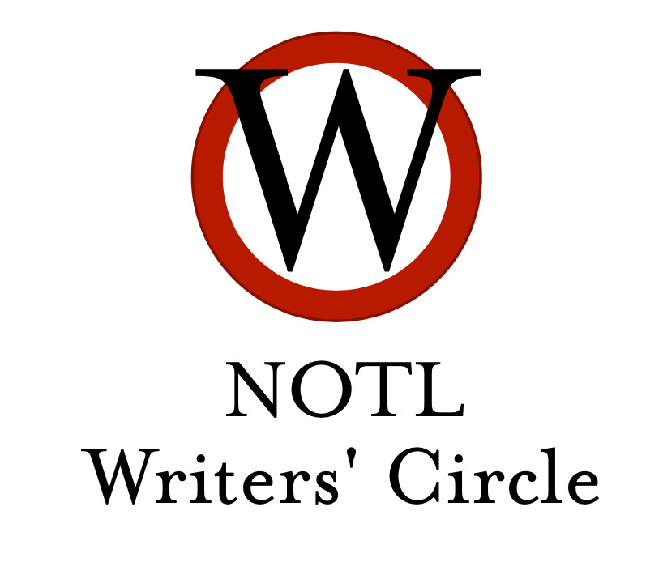
How to write good better prose

Here are suggestions from members of the NOTL Writers’ Circle.
Just like a prescribed medication, use as needed...one at a time.
Best taken with food and drink.

Stephen King, On Writing: A Memoir of the Craft
“If you don't buy another book on writing, you could do worse than this critically acclaimed bestseller. It reads like a novel and covers every tool of the trade. King provides a fascinating account of his own process, and journey as a writer. Strongly recommended for anyone who wants the whole story.”

Stanley Fish, How to Write a Sentence and How to Read One
“This book explores the craft of writing anything, examining the prose styles of great writers, and gleaning the qualities of good sentences vs bad (that often pass for good). It's also an excellent guide for anyone who wants to know what to look for while reading great books.”

John Gardner, The Art of Fiction
“Probably too academic for many tastes and requirements, but it has a section devoted to common "howlers" in writing that should be avoided at all costs.”

James Wood, How Fiction Works
“Another favorite, though a familiarity with some classic literary writers is an advantage in reading this book. Sections on character, dialogue, language, etc.”

Harry Bruce, Page Fright
“A must-read for anyone who writes. No rules for writing better, but a fascinating account of the 'foibles and fetishes' of great writers. Hilarious at times, but mostly just absorbing and enlightening. Whatever weird habits and rituals you have when writing, you are not alone.”

Bill Bryson, The Penguin Dictionary for Writers and Editors
“A handy reference to correct usage, spelling and meanings of troublesome words. Easy to use; not at all pedantic, and most helpful.”

Meredith Maran (ed), Why We Write
“Twenty acclaimed writers talk about why they write and how. Insightful and a joy to read.”

Barnaby Conrad and Monte Schulz (eds), Snoopy's Guide to the Writing Life
“No joke! A wonderful book, illustrated with all the comic strips of Snoopy at his typewriter, from the beginning ("It was a dark and stormy night"), followed up by commentary from a famous writer commenting. So, you get Danielle Steele, Ed McBain, Ray Bradbury, Julia Child, William Buckley Jr., and a host of others, talking about every aspect of writing you can think of.”
John McPhee, On the Writing Process
“Apart from a chapter where he provides a diagrammatic account of the process, this book has much to offer, especially on the importance of writing many drafts and revisions. Fascinating look at writing from a Princeton teacher with a lengthy history with The New Yorker.”

Moira Allen, Writing to Win: The Colossal Guide to Writing Contests
“A comprehensive guide to fiction, non-fiction, and poetry contests worldwide (in English), with URLS, so you can check the current status of the competition. This book is invaluable if you want to put your work out there: novels, short stories, memoirs, poetry...it has everything. Be prepared to hear nothing back from your submissions, but always be open to surprises!”

Nancy Sakaduski, How to Write Winning Short Stories
“This is as close to a writing manual as I can imagine. It's not gimmicky at all, quite liberal with the "rules" of writing, and very useful for the writer who wants to know the main pitfalls in writing as well as the objectives and techniques.”

Anne Lamott, Bird by Bird
“A beautiful read, this book is full of wisdom and joy. Worth reading even if one is not an author. My absolute favourite.”

Ursula K. Le Guin, Steering the Craft
“Contains prompts and exercises, and as you would expect from this author, beautifully written.”

Zoe Fairbairns, Write Short Stories and Get them Published
“Excellent content, and she expects you to work. There are many writing prompts.”

Robert Olen Butler, From Where You Dream
“Very different, thought-provoking. A series of lectures transcribed by adoring students of a prof who would not put his advice to paper.

Douglas Glover, Attack of the Copula Spiders
“The first essay on writing short stories is worth the price of the book.”

William Strunk Jr and E.B. White, The Elements of Style
“You probably used this one in school, but it’s still a classic.”

Benjamin Dryer, Dryer’s English

Francine Prose, Reading Like a Writer

Renni Browne and Dave King, Self-Editing for Fiction Writers

Joseph M. Williams, Style - Toward Clarity and Grace

